31st July 2018

**YOKOHAMA Develops Car A/C Hose to Facilitate US Automakers’ Shift to Next-generation Refrigerant, Contributes to the Global Warming Prevention**

YOKOHAMA has developed the “ACBR series” of hoses for use in car air conditioners. The new hoses are compatible for use with HFO-1234yf, which is seeing more widespread application as the next-generation refrigerant for car air conditioners. The ACBR series includes both high- and low-pressure hoses, which have already been adopted in the all-new 2018 “Jeep® Wrangler” and the all-new 2018 “Jeep® Compass”.   
  
Automobile makers are gradually shifting from the current standard refrigerant, HFC-134a, to HFO-1234yf as part of their efforts to make more environmentally friendly cars that contribute less to global warming. HFO-1234yf has a GWP (global warming potential) of just 4, compared with HFC-134a’s very high 1,430. However, faster adoption of HFO-1234yf has been hindered by its decomposition over long periods of time, which causes the release of acids that corrode the resin layer on the inner surface of the hose. To date, countermeasures have included a method for improving the resin material* and a method to prevent contact between the resin and the refrigerant. Responding to a request from a US automaker, YOKOHAMA has developed a hose structure with a rubber layer inside the resin layer. The development of an inner rubber with improved adhesion to resin was the key to the development of the new ACBR Series of hoses that prevent direct contact between the refrigerant and resin layer, thereby preventing leakage of the refrigerant caused by corrosion of the inner resin layer. YOKOHAMA has applied patents from Japan for the compound material used in the hoses with this newly developed inner rubber layer.   
  
As part of its ongoing effort to expand its automobile parts business on a global scale, YOKOHAMA plans to develop a full line-up of these new barrier-type hoses and further strengthen overseas sales.  
  
* Please see

<http://www.y-yokohama.com/release/?id=2443&lang=en&sp=20&category=0103> for an April 2015 release on YOKOHAMA’s development of the AC6B-11 hose, which used an improved resin material to be compatible for use with the HFO-1234yf refrigerant.

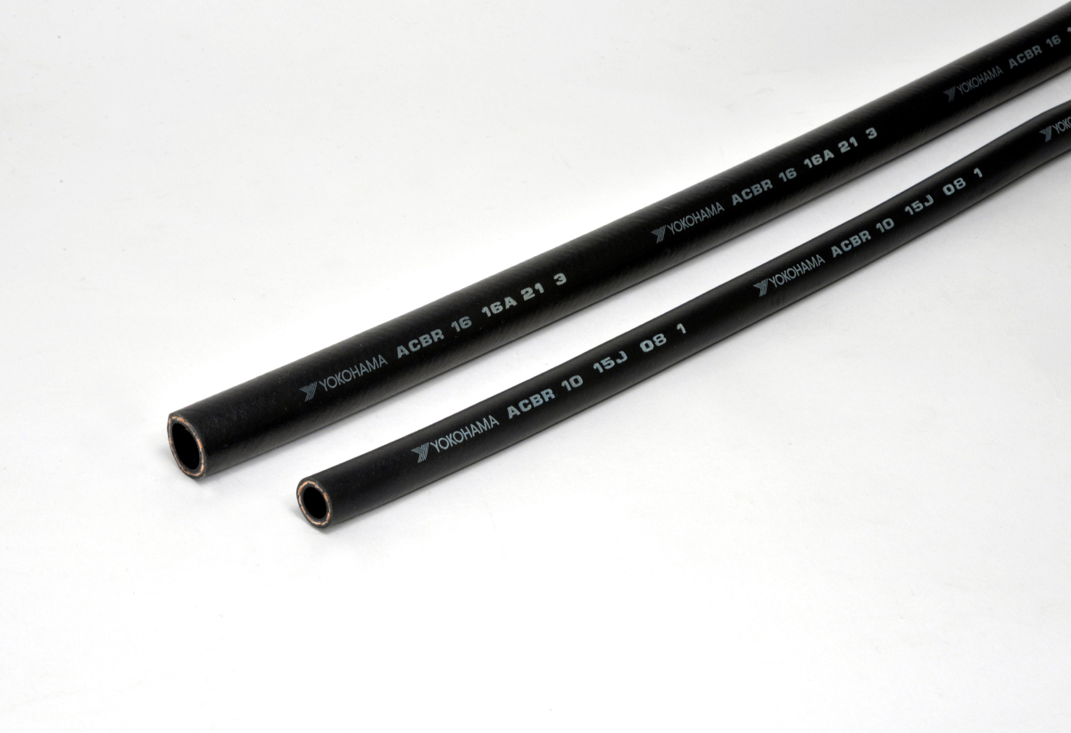

*Outside surface of an ACBR Series hose*

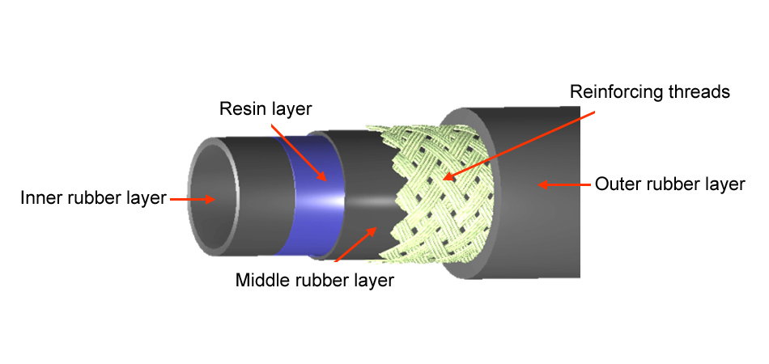

*Structure of new ACBR Series hoses*